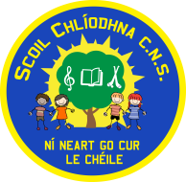
Scoil Chlíodhna Community National School
Carrigtwohill GAA, Carrigtwohill, Co. Cork.
Phone: 086-0080268
www.scoilchliodhnacns.ie
Pre – Enrolment form

Child’s Information
Child’s First Name: ………………………………… Child’s Last Name: …….…………………………………
Date of Birth: ………………………………… Gender (please tick √): Male Female
Year for which child is being enrolled: ………………………………………..
Class for which child is being enrolled: ……………………………………….
Name and address of preschool/playschool attended, if applicable: …………………….…………………………
……………………………………..……………………………………………………………………………………………………………..…
Name and address of previous school attended, if applicable: …………………….……………………….…………
……………………………………..……………………………………………………………………………………………………………..…

Parent(s)/Guardian(s) Information
Name(s): ………………………………………………………………………………………………………………………
Address: ………………………………………………………………………………………………………………………
................……………………………………………………………………………………………………...
Phone Number(s): ………………………………………………………………………………………………………………………
Email(s): ………………………………………………………………………………………………………………………

I understand that:
- Registration alone does not guarantee a place in the school. Decisions in relation to applications for enrolment are made by the Board of Management in accordance with this enrolment policy.
- It is my responsibility to inform the school of any change of contact details or other relevant circumstances

Please sign and send the completed application form to the above address.
Signed: ………………………………………………………………………………………………………………………
Date: ………………………………………………………………………………………………………………………

All Application Forms should be returned to:
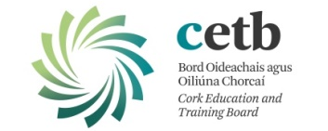
Scoil Chlíodhna Community National School,
Carrigtwohill GAA,
Carrigtwohill,
Co. Cork.

